A MINI PROJECT REPORT
ON
FORM DESIGN

Table of Contents
1. Introduction 3
1.1 Key Features of Form Design 3
2. Objectives 3
3. Technologies Used 4
4. System Architecture 4
5. Flow Diagram and Explanation 5
6. Module Description 6
7. Implementation (Code Overview) 6
8. User Interface (Sample Design) 7
9. Advantages 7
10. Conclusion 8
11. References 8

1. Introduction
A Form Design application is a web-based system that enables users to create, customize, and submit forms online. These forms are widely used in various domains such as education, business, healthcare, and government sectors for purposes like data collection, surveys, registrations, feedback gathering, and customer interaction.
With the rapid growth of digital transformation, traditional paper-based forms are being replaced by online form systems that offer efficiency, accessibility, and automation. A well-designed form not only collects data but also enhances user experience by ensuring ease of use, clarity, and responsiveness.
Modern form design applications integrate interactive components and intelligent validation mechanisms to reduce errors and improve data quality. These systems are often integrated with databases and analytics tools, enabling organizations to make informed decisions based on collected data.

1.1 Key Features of Form Design
- Drag and Drop Builders: Users can easily add, remove, or rearrange form elements such as text fields, checkboxes, radio buttons, and images without technical knowledge.
- Ready-made Templates: Pre-designed templates help users quickly create forms for surveys, registrations, or feedback systems.
- Customization & Branding: Forms can be customized with logos, colours, themes, and layouts to match organizational branding.
- Data Validation & Logic: Built-in validation ensures correct data entry, while conditional logic enables dynamic form behaviour.
- Integration & Sharing: Forms can be embedded in websites or shared via links and integrated with tools like email services and cloud storage.

2. Objectives
The main objectives of the Form Design project are:
- To design user-friendly and interactive forms.
- To collect and store user data efficiently.
- To validate user inputs and reduce errors.
- To provide a responsive user interface across devices.
Additional goals include:
- Maximize Completion Rates:
Reducing user effort ensures forms are completed and submitted successfully.
- Ensure Data Accuracy:
Clear labels and validation rules improve the quality of collected data.
- Minimize Cognitive Load:
Simple layouts and logical grouping enhance user understanding.
- Improve Accessibility:
Forms should be usable by all users, including those with disabilities.
- Build Trust and Security:
Secure data handling increases user confidence.

3. Technologies Used
The project uses the following web technologies:
- HTML (Hypertext Markup Language): Provides the structure of the form including input fields, labels, and buttons.
- CSS (Cascading Style Sheets): Enhances the visual appearance of the form through styling, layout, colours, and responsiveness.
- JavaScript: Adds interactivity and functionality such as validation, dynamic content, and user feedback.
These technologies work together to create a complete front-end web application.

4. System Architecture
The system architecture of the Form Design application follows a simple flow:
User → Form UI → Validation → Data Processing → Output/Storage
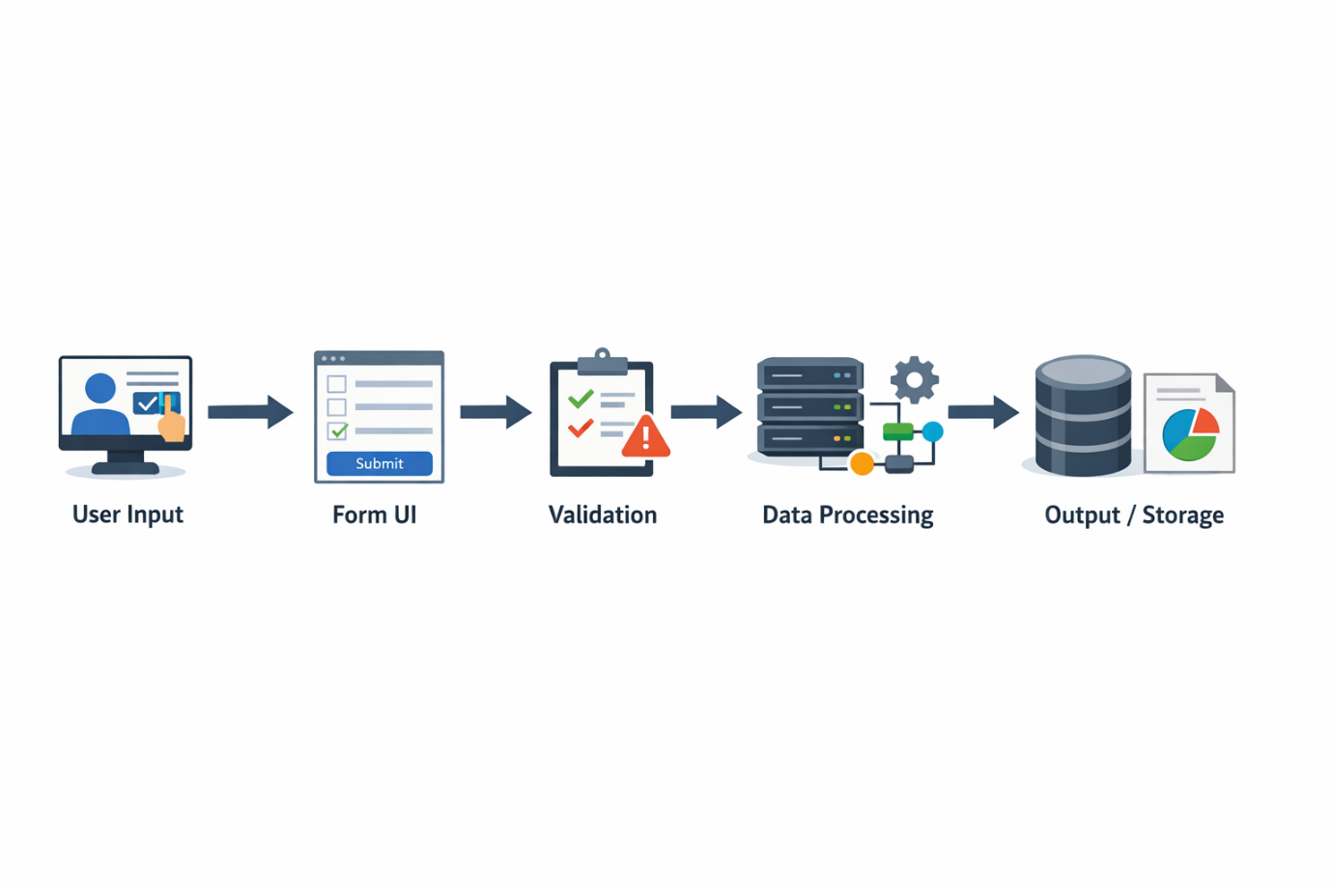
Figure 4.1: System architecture flow diagram
Components:
- Form Builder:
Allows administrators to design forms by adding fields and defining rules.
- Form Renderer:
Converts the form structure into a user interface displayed to users.
- Schema/Metadata Store:
Stores form structure and configuration.
- Backend Integration:
Handles data submission, processing, and storage in databases.
This architecture ensures smooth data flow from user input to storage and output.

5. Flow Diagram and Explanation
User Flow Steps:
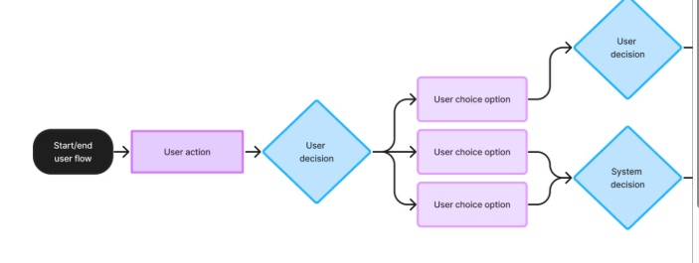
Figure 5.1 User flow diagram
- User opens the form
- User enters data
- System performs validation
- If valid → Form is submitted
- If invalid → Error messages are displayed
Explanation:
The process begins when a user accesses the form. After entering the required information, the system checks the data for accuracy using validation rules. If the data meets all conditions, it is submitted and stored. If errors are found, appropriate messages guide the user to correct them.

6. Module Description
The system is divided into the following modules:
- Input Module: Captures user data through various input fields.
- Validation Module: Ensures correctness of input using rules like required fields, format checks, etc.
- Submission Module: Processes and sends data to the backend or storage system.
- Display Module: Shows confirmation messages or error alerts to users.
Each module plays a crucial role in ensuring smooth functionality.

7. Implementation (Code Overview)
HTML Code:
HTML is used to structure the form, including:
- Input fields (text, email, password)
- Labels
- Buttons (submit/reset)
Example elements:
- <form>
- <input>
- <label>
- <button>
CSS Code:
CSS is used to enhance design:
- Layout alignment
- Colors and fonts
- Responsive design for mobile devices
Example properties:
- margin, padding
- background-color
- border-radius
JavaScript Code:
JavaScript handles:
- Form validation
- Dynamic behaviour
- Error messages
Example functions:
- Checking empty fields
- Validating email format
- Displaying alerts

8. User Interface (Sample Design)
Student Registration Form
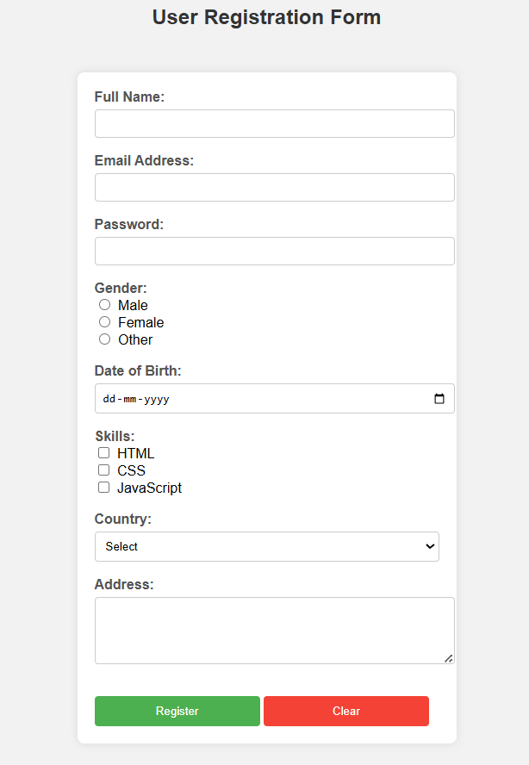
Figure: 8.1 Student registration form
Description:
- Clean and simple layout
- Clearly labelled input fields
- Submit button for data submission
- Message display area for feedback
A good UI design improves usability and ensures users can complete forms quickly and accurately.

9. Advantages
- Easy to Use:
Simple interface allows users to fill forms without confusion.
- Saves Time:
Faster than traditional paper-based systems.
- Reduces Paperwork:
Promotes digital data collection.
- Fast Data Collection:
Instant submission and storage.
- High Efficiency & Automation:
Automated validation and processing.
- Data Accuracy & Security:
Reduces human errors and ensures safe storage.
- Seamless Integration & Analytics:
Can be connected with databases and reporting tools.
- Enhanced Customization & Branding:
Supports personalized design and branding.

10. Conclusion
The Form Design application is an effective solution for modern data collection needs. It demonstrates how HTML, CSS, and JavaScript can be combined to create interactive and responsive web applications.
The project highlights the importance of usability, accessibility, and data validation in form design. By implementing features such as drag-and-drop builders, conditional logic, and responsive layouts, the system ensures a seamless user experience.
In today’s digital world, form design applications play a vital role in streamlining processes, improving data accuracy, and enhancing user engagement. Future improvements can include backend integration, database connectivity, and advanced analytics for better insights.

11. References
W3Schools. (2024). HTML Tutorial. Available at: https://www.w3schools.com/html/
W3Schools. (2024). CSS Tutorial. Available at: https://www.w3schools.com/css/
Mozilla Developer Network (MDN). (2024). JavaScript Guide. Available at: https://developer.mozilla.org/en-US/docs/Web/JavaScript/Guide

